**NAÏVE BAYES APPLICATION**

**Step 1:** open the weka explorer

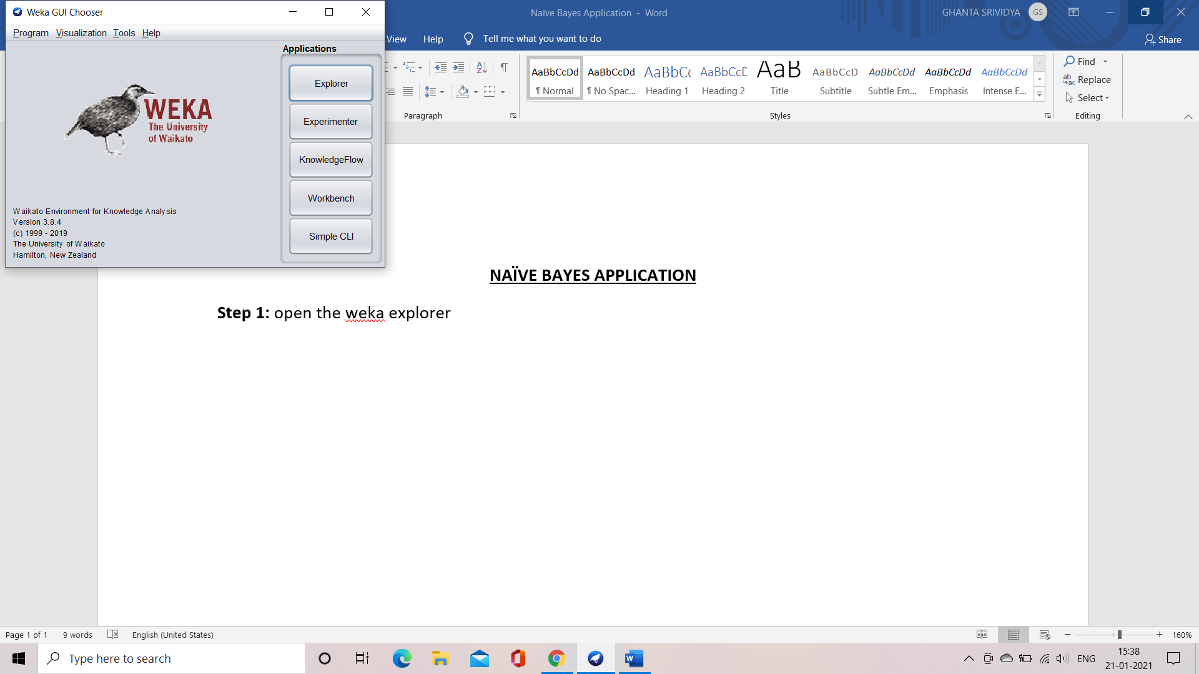

**Step 2:** load the German credit dataset into weka

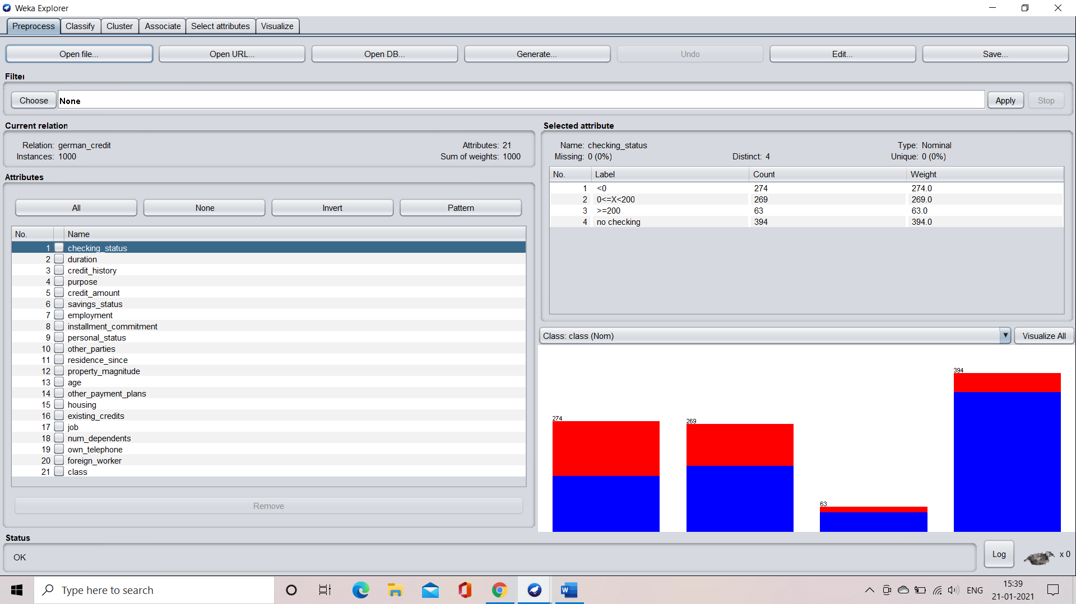

**Step 3:** select the classify tab

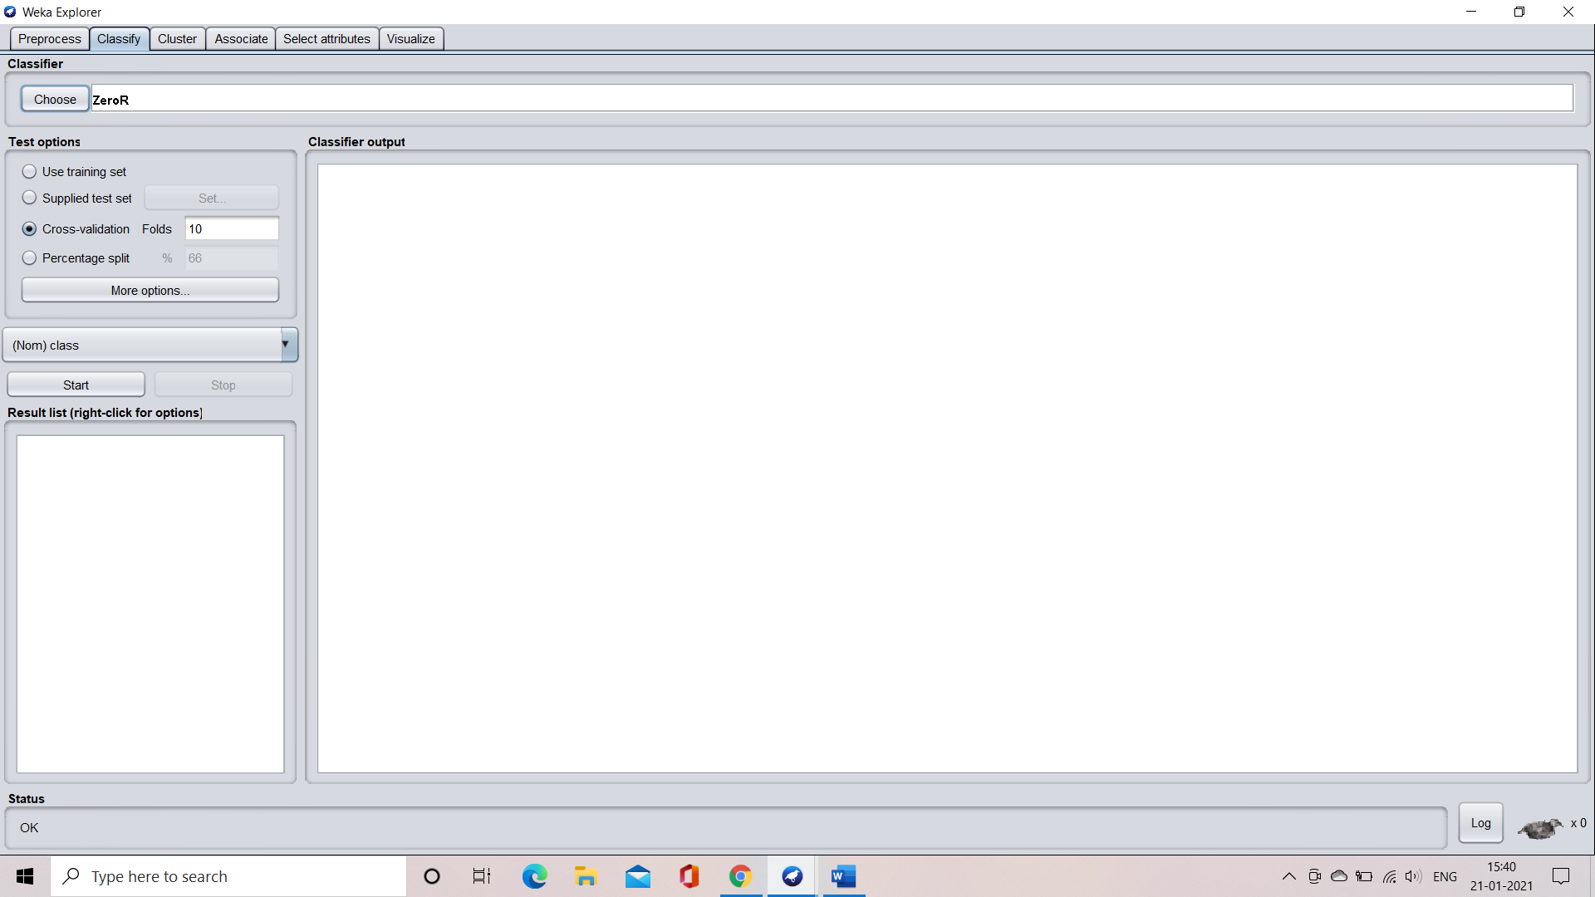

**Step 4:** select the choose button and select the naïve bayes option

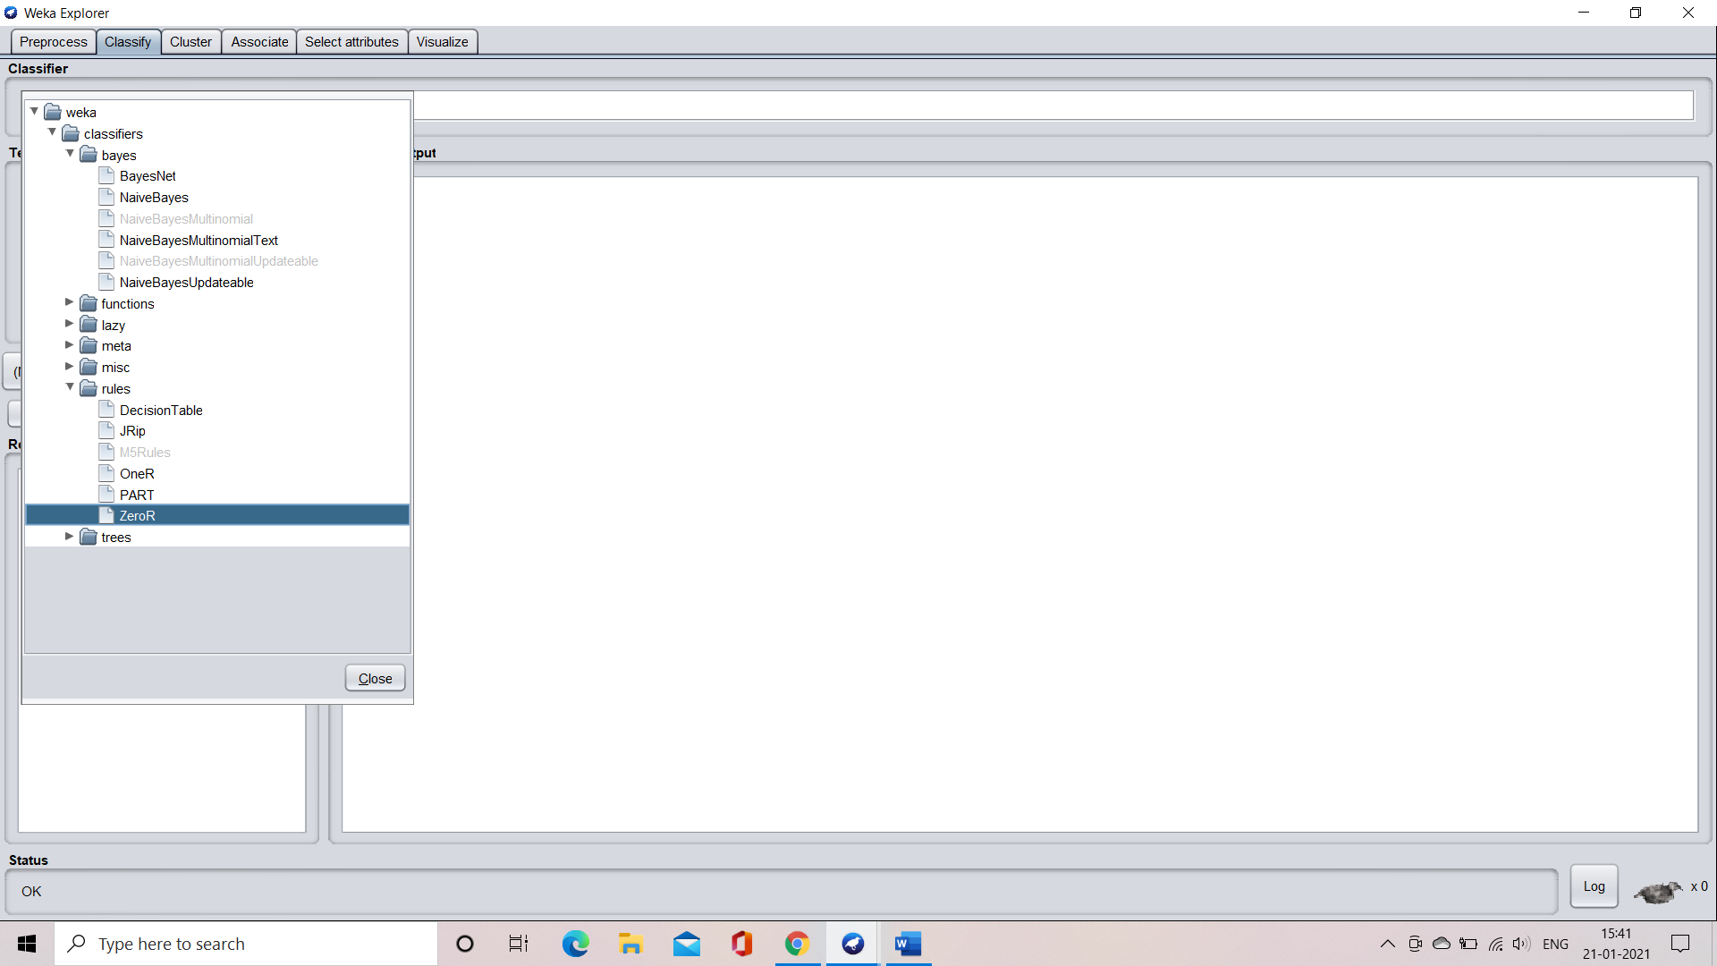

**APPLICATION OF NAÏVE BAYES USING TRAINING SET**

**Step 1: select the using training set option and click the start button to train the machine**

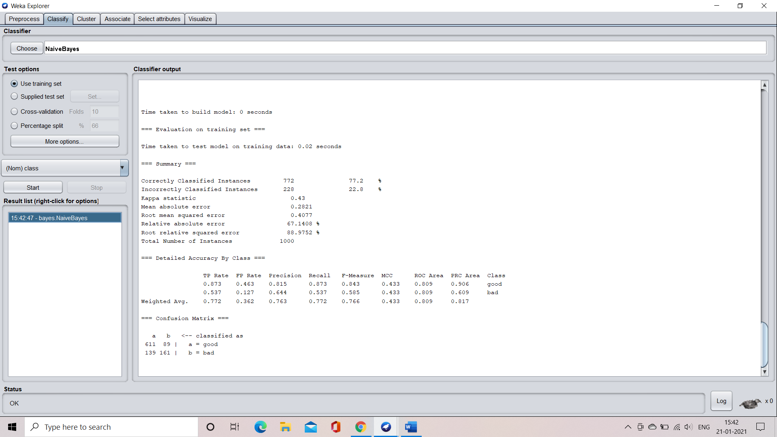

**Step 2:** understand the characteristics of the algorithm

Time taken to bulid the model = 0 seconds

Time taken to test the model on the training data = 0.02 seconds

**Confution matrix:**



**Accuracy:**



**Visualization of the model**

**Margin curve:**

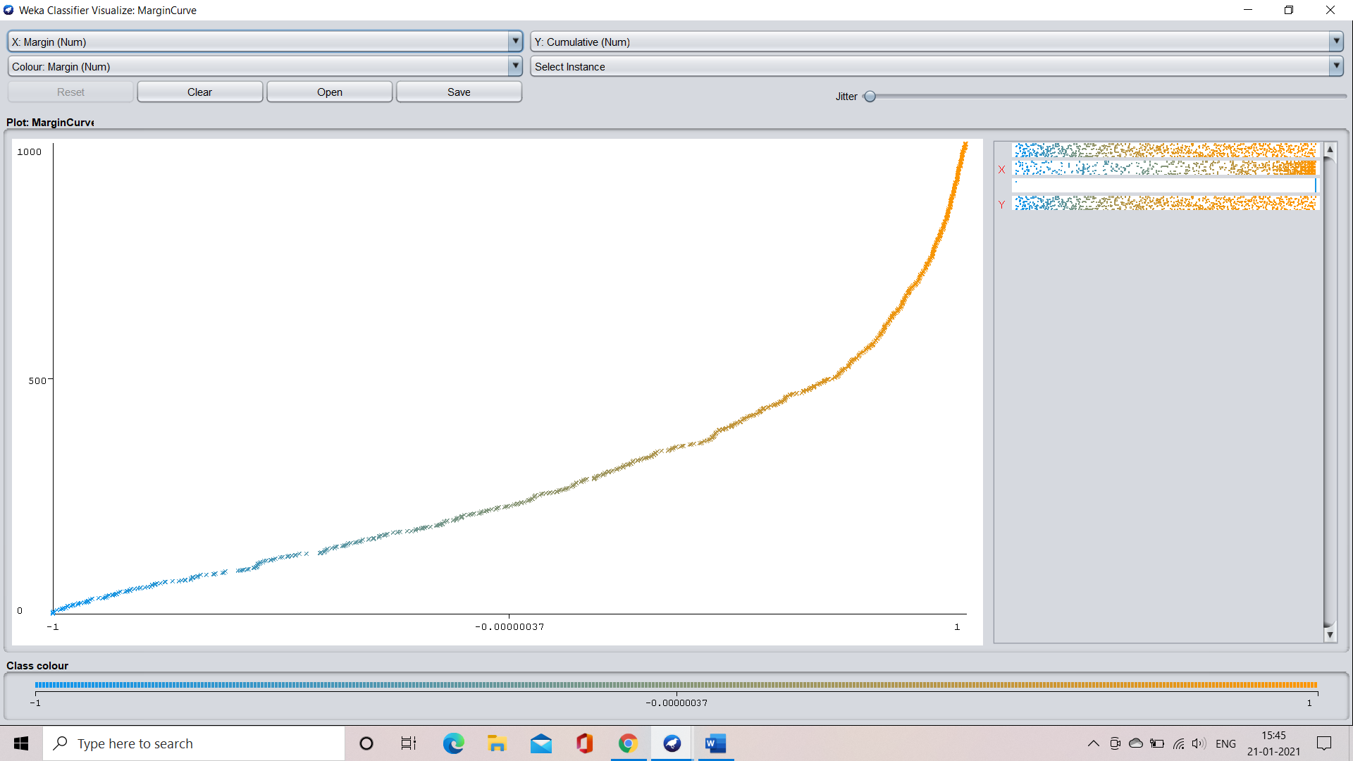

**Threshold curve for the class: good**

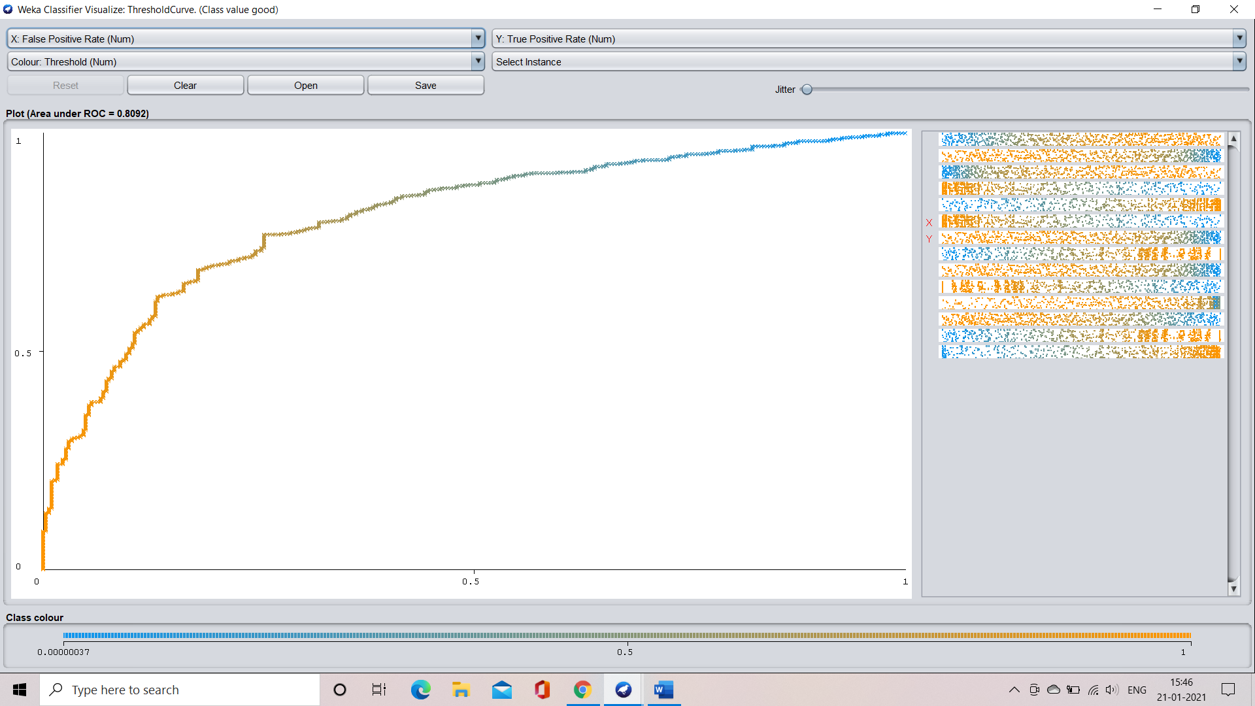

**Threshold curve for class:bad**

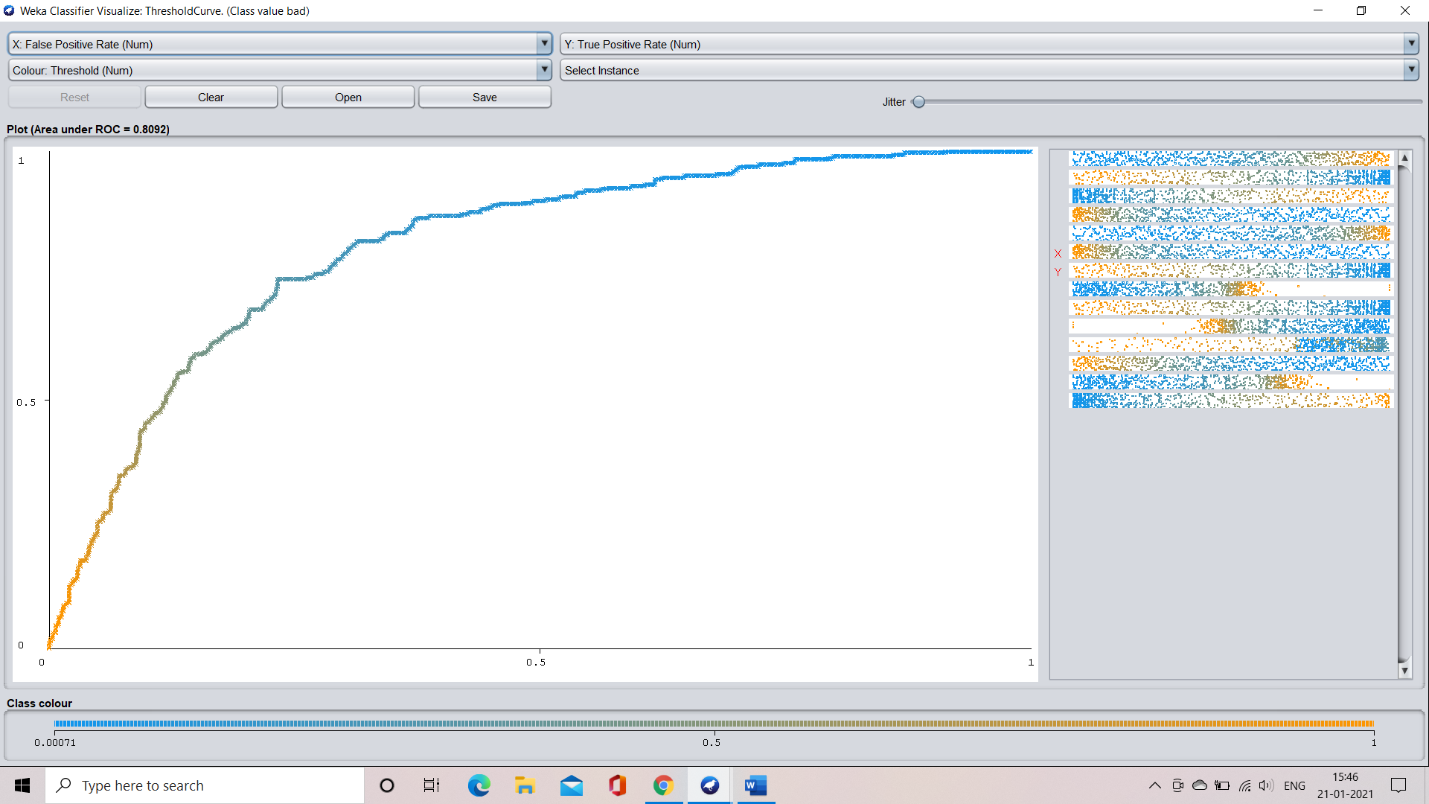

**APPLICATION OF NAÏVE BAYES USING CROSS VALIDATION**

**CASE 1: application when the fold count is 10**

**Step 1:** select the cross validation option and specify the count of the fold which is 10 in our case

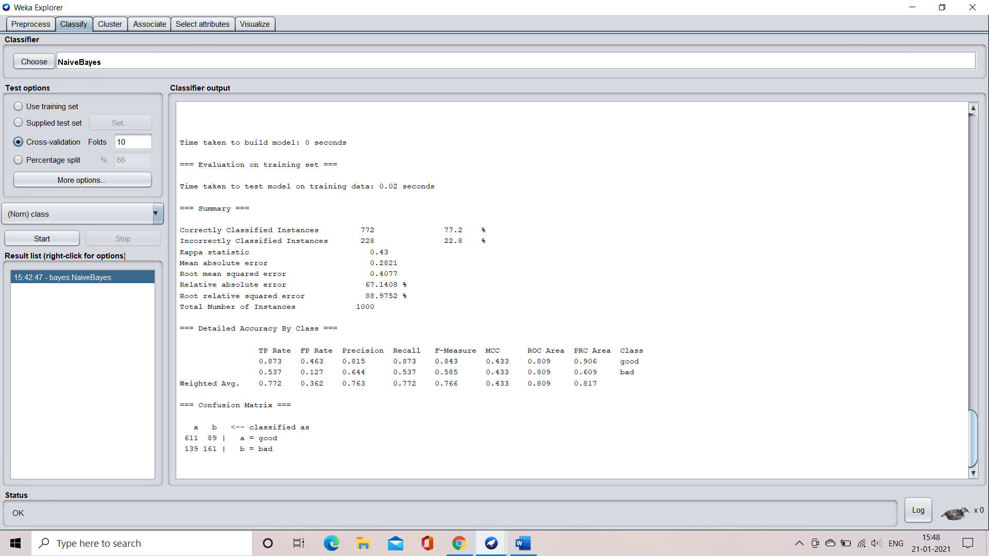

**Step 2:** train the machine by clicking the start button

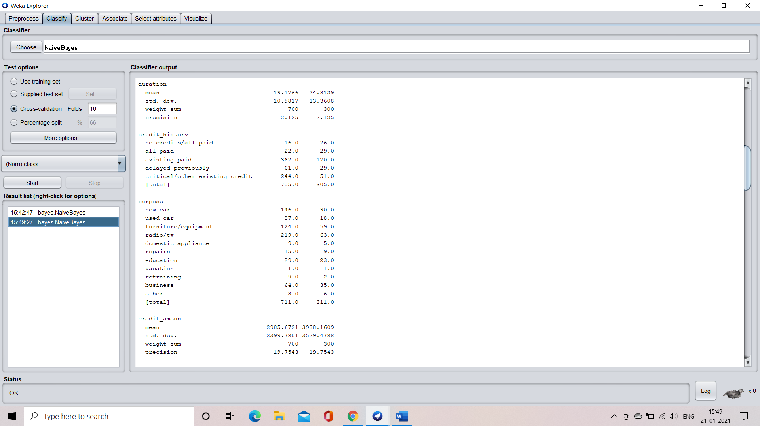

**Step 3:** understand the characteristics of the model

Time taken to build the model = 0 seconds

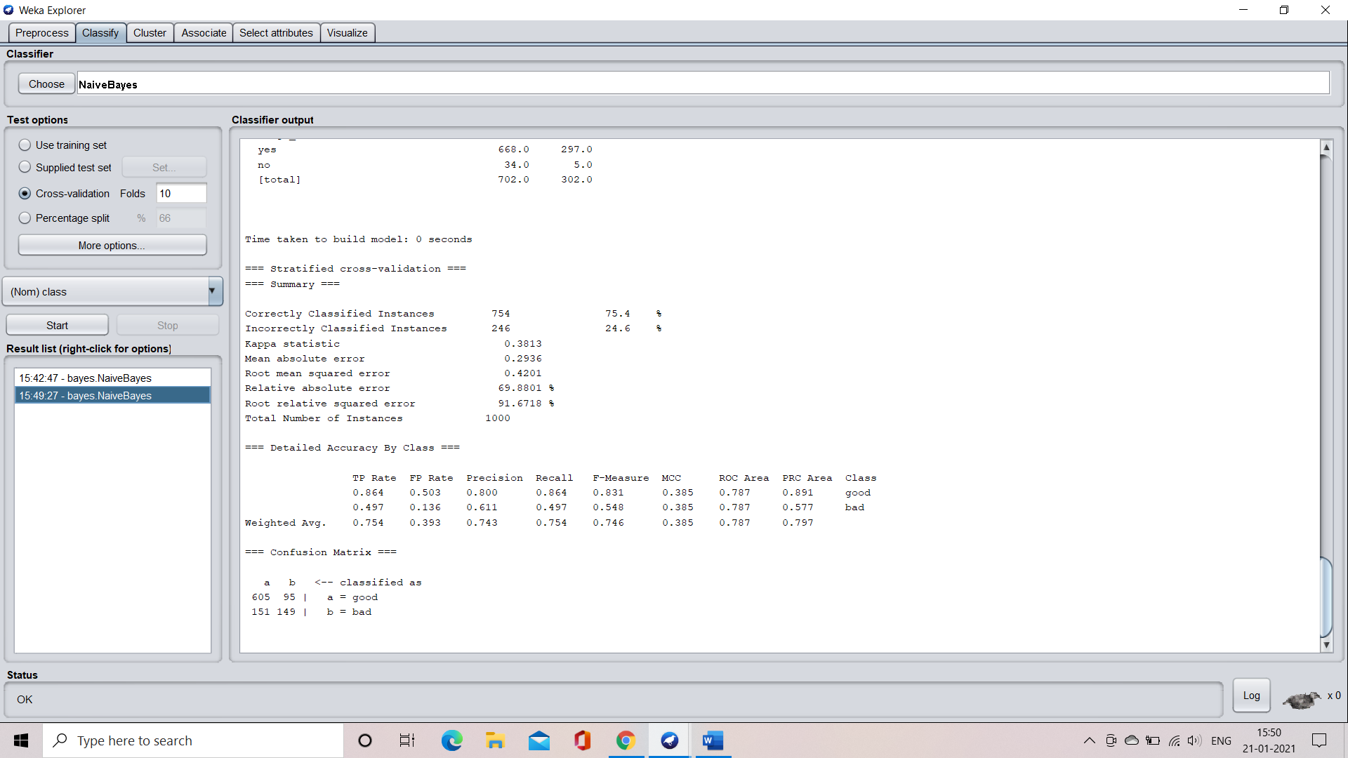

**Confusion matrix:**



**Accuracy:**



**Visualization of the model**

**Margin curve:**

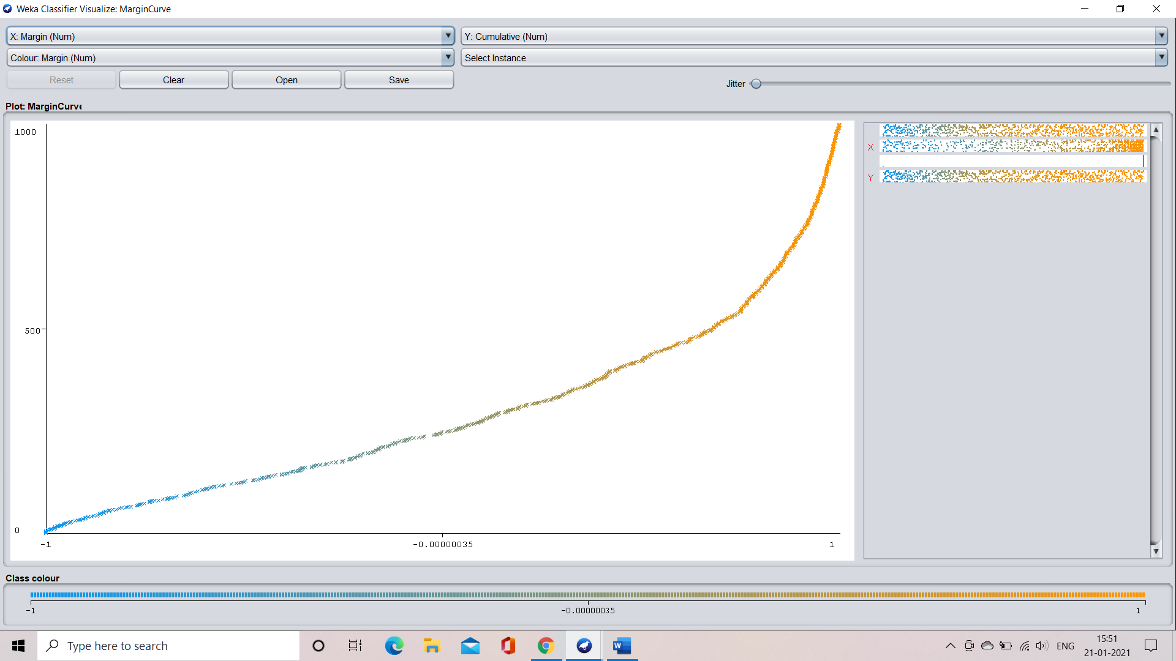

**Threshold curve for the calss: good**

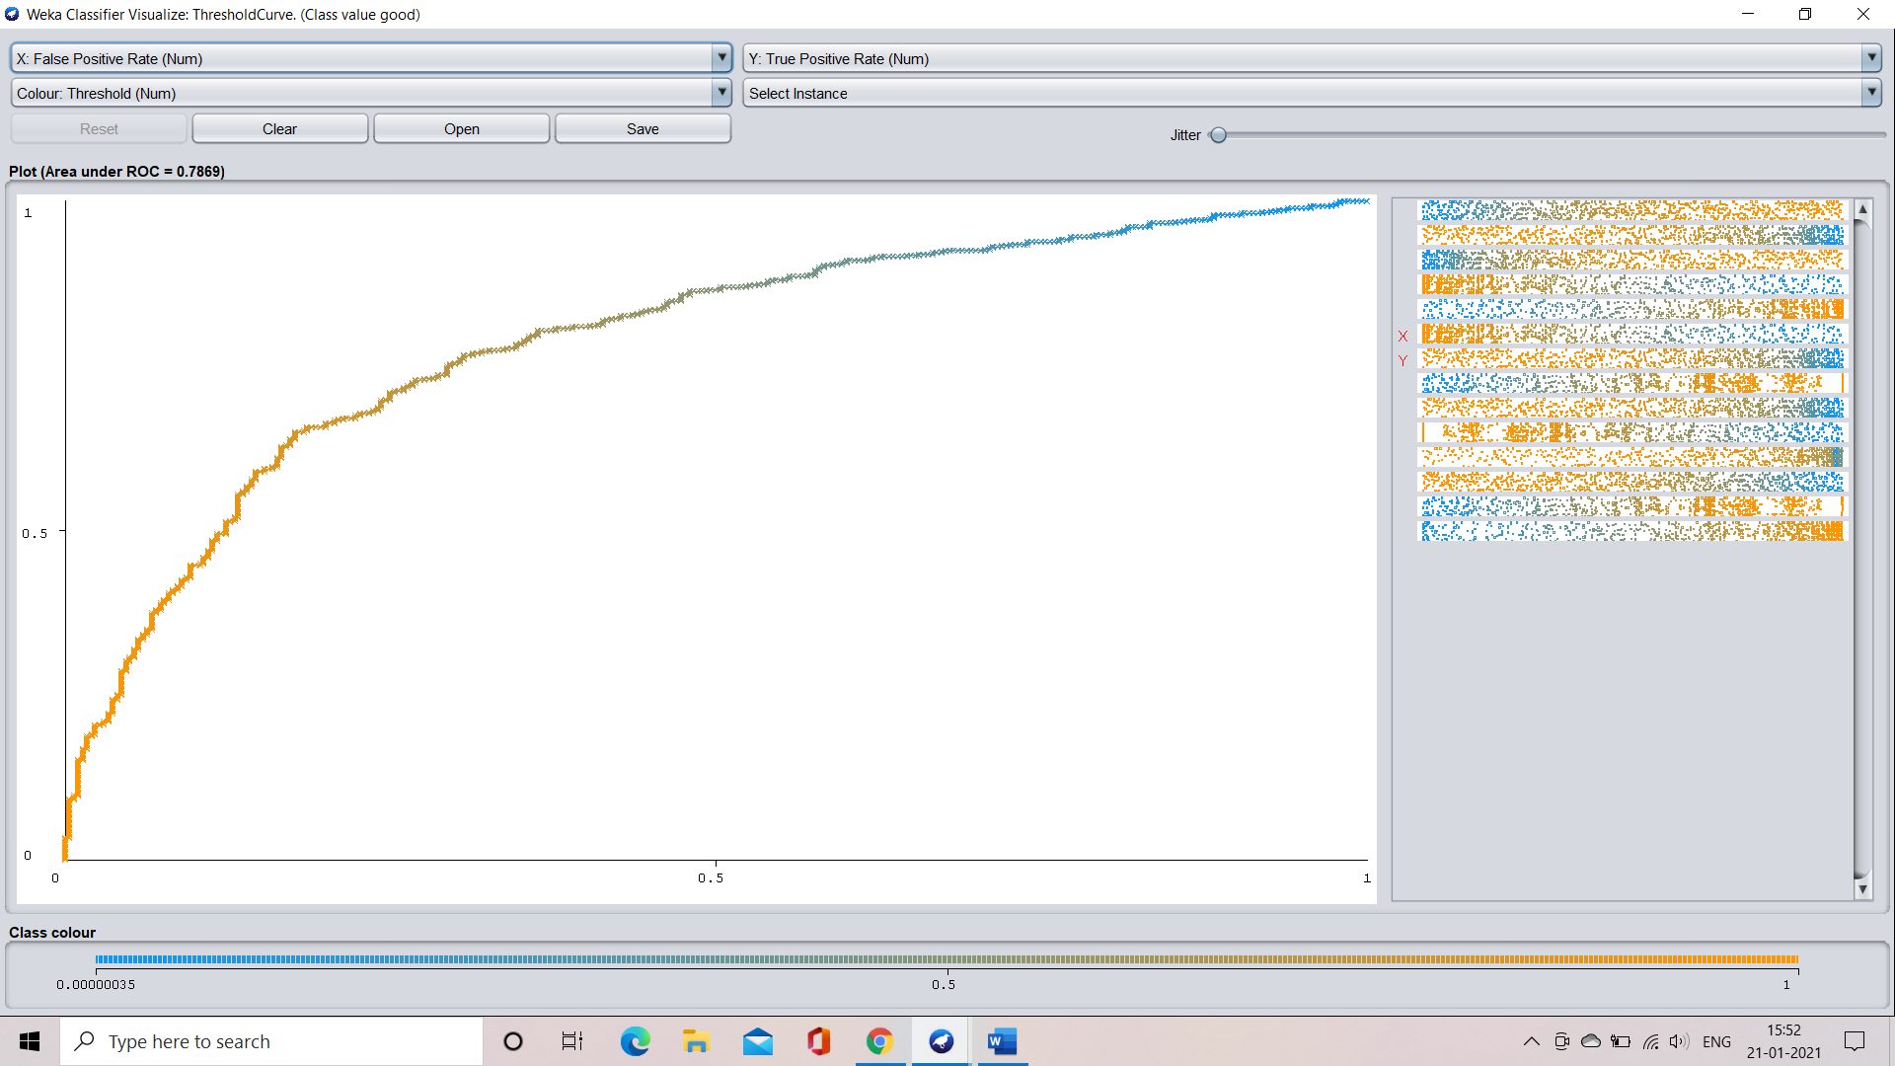

**Threshold curve for the class value: bad**

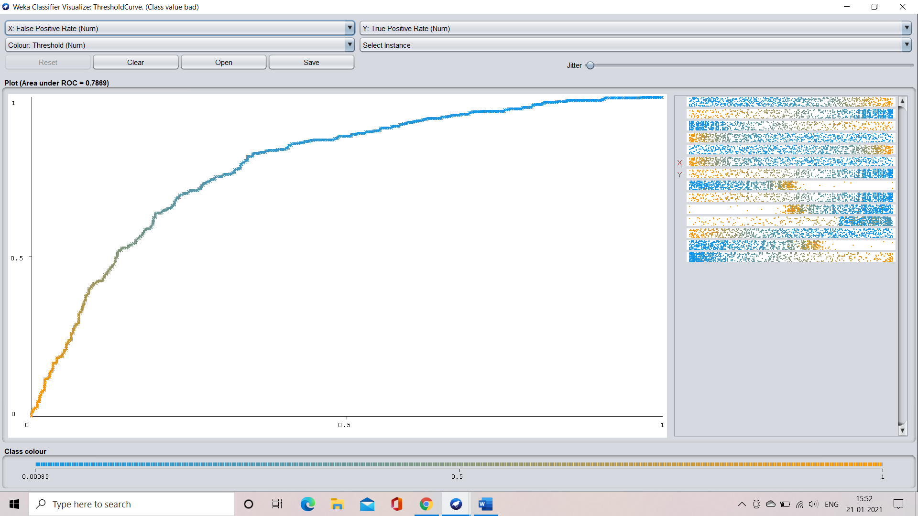

**CASE 2: application when the fold count is 8**

**Step 1:** select the cross-validation option and specify the fold count which is 8 in our case

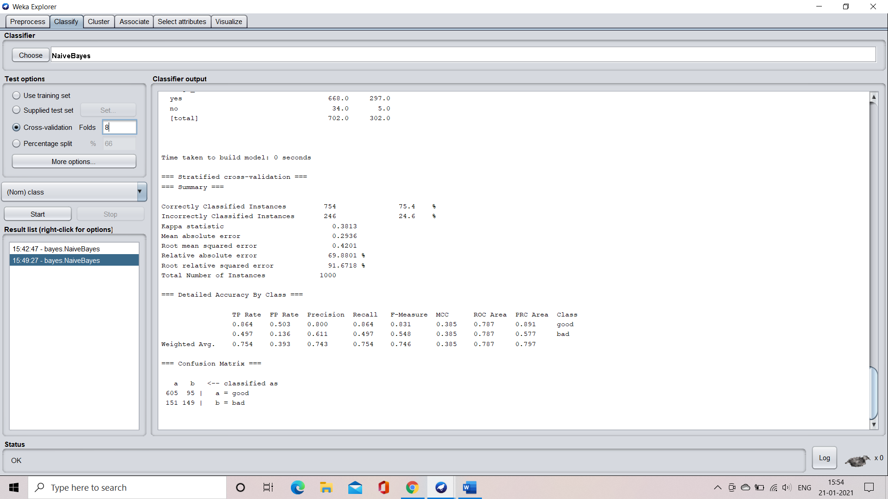

**Step 2:** train the machine by clicking the start button

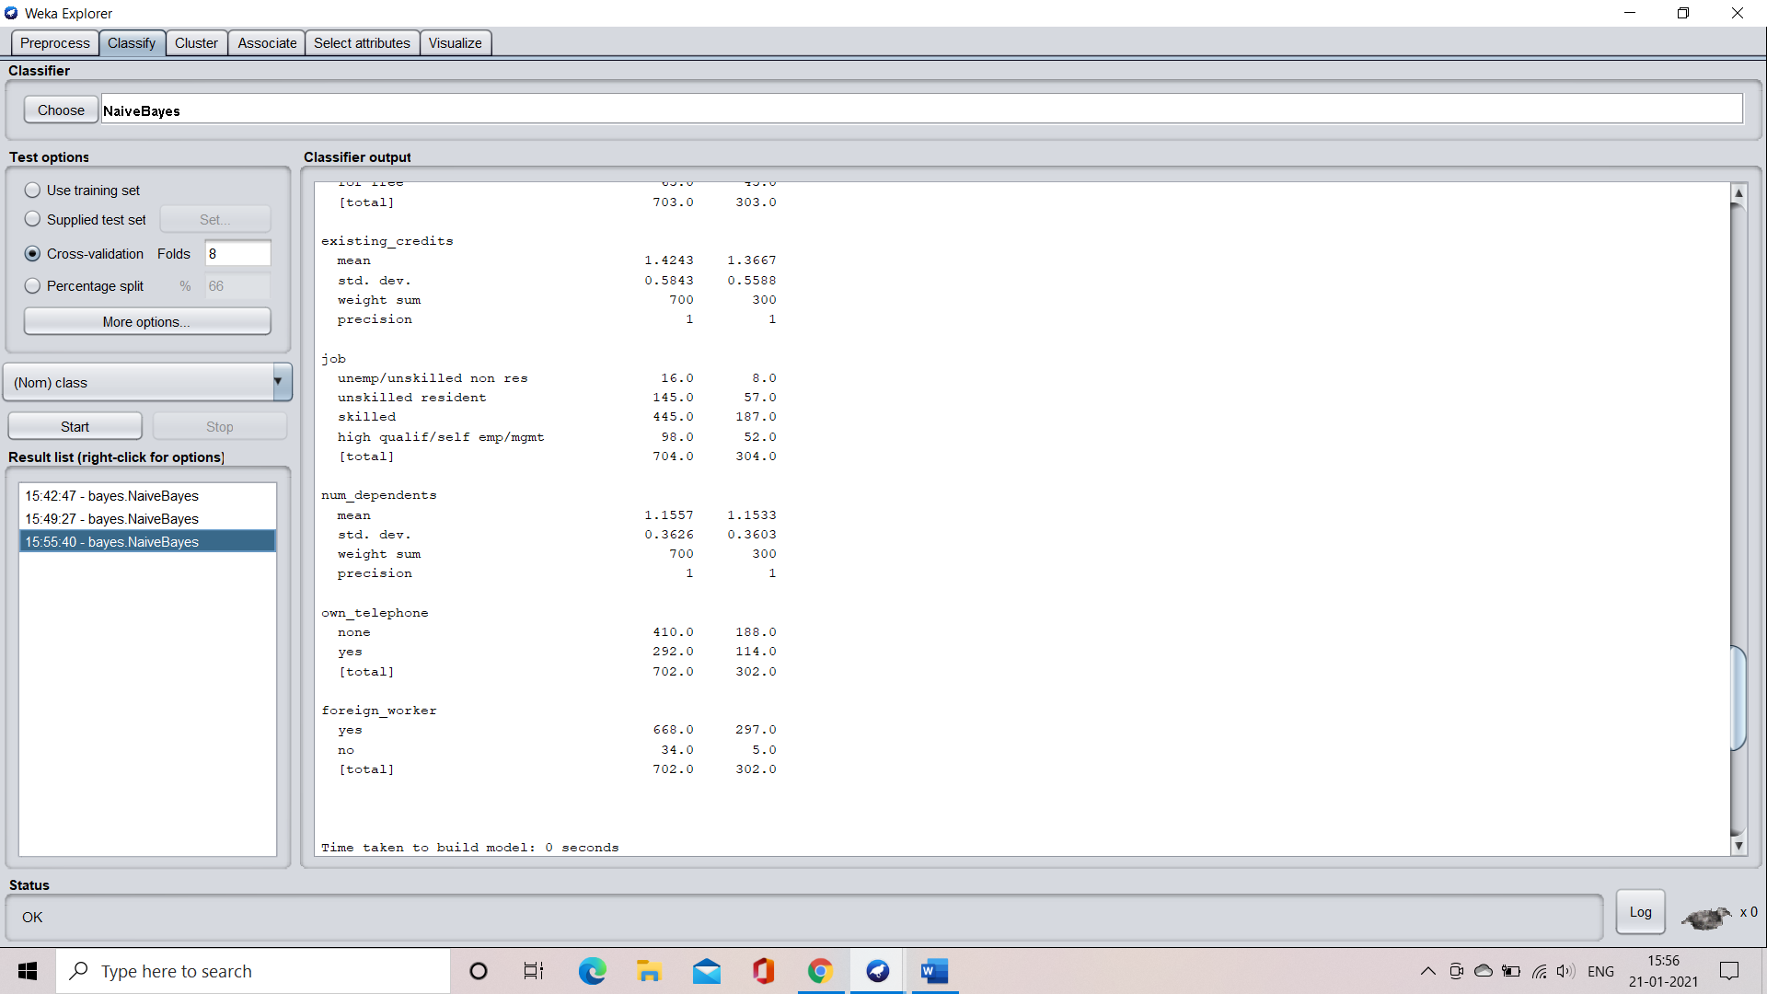

**Step 3:** understand the characteristics of the model

Time taken to build the model = 0 seconds

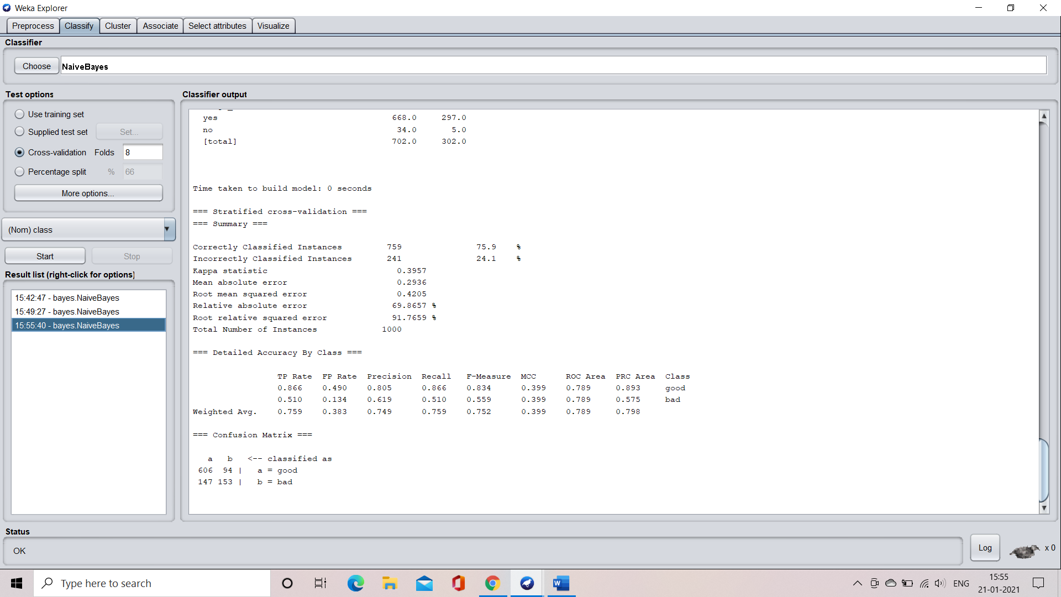

**Confusion matrix:**



**Accuracy:**



**Visualization of the model**

**Margin curve:**

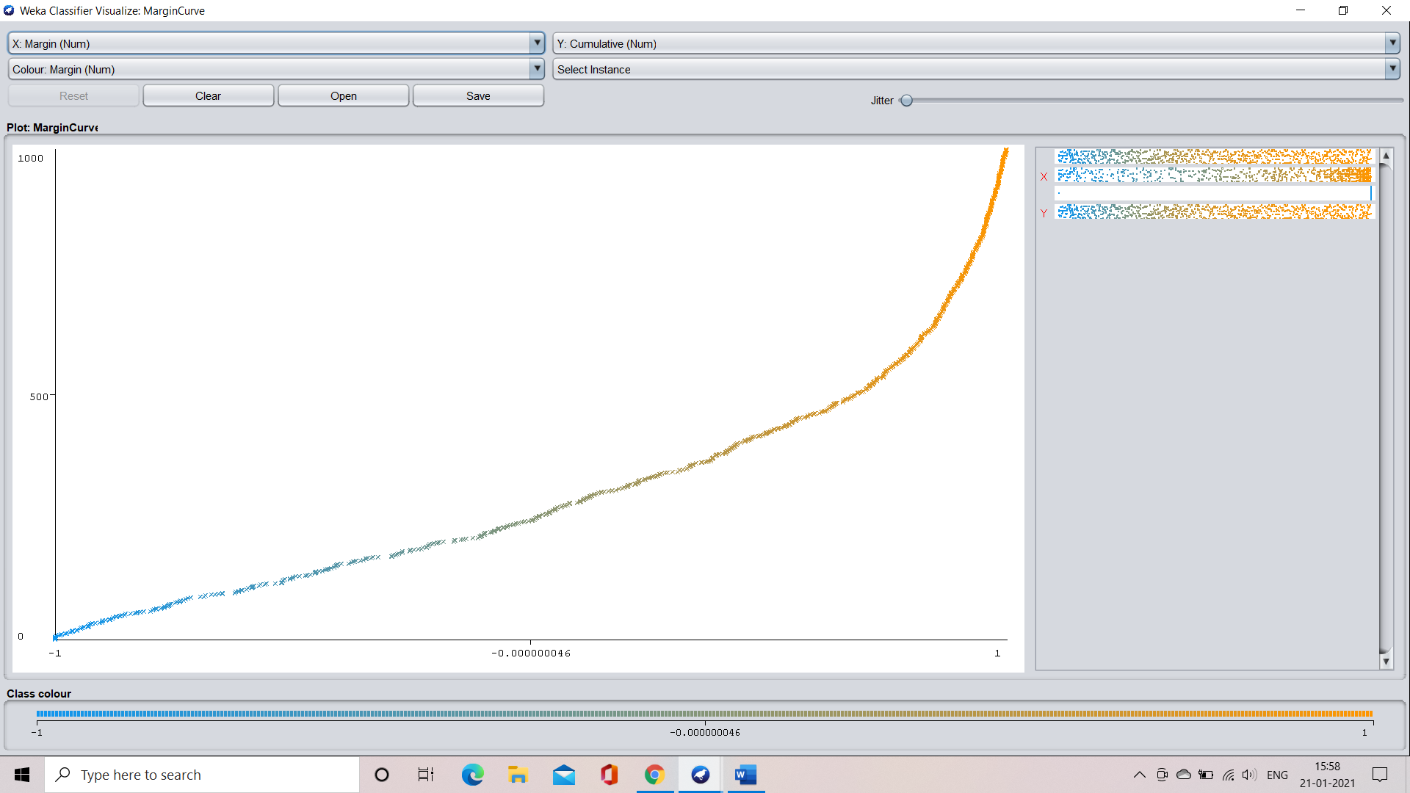

**Threshold curve for class: good**

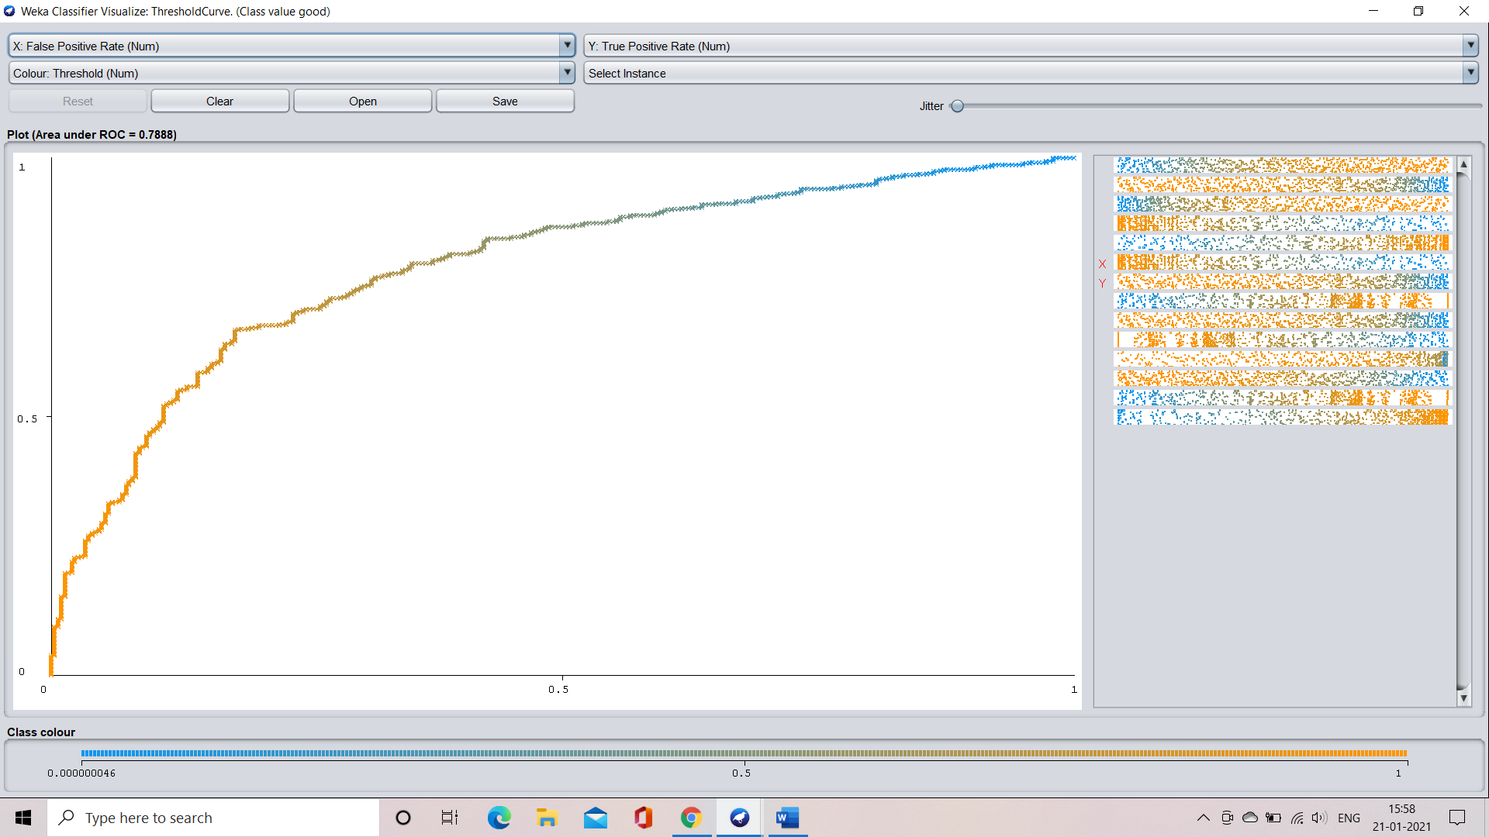

**Threshold curve for class: bad**

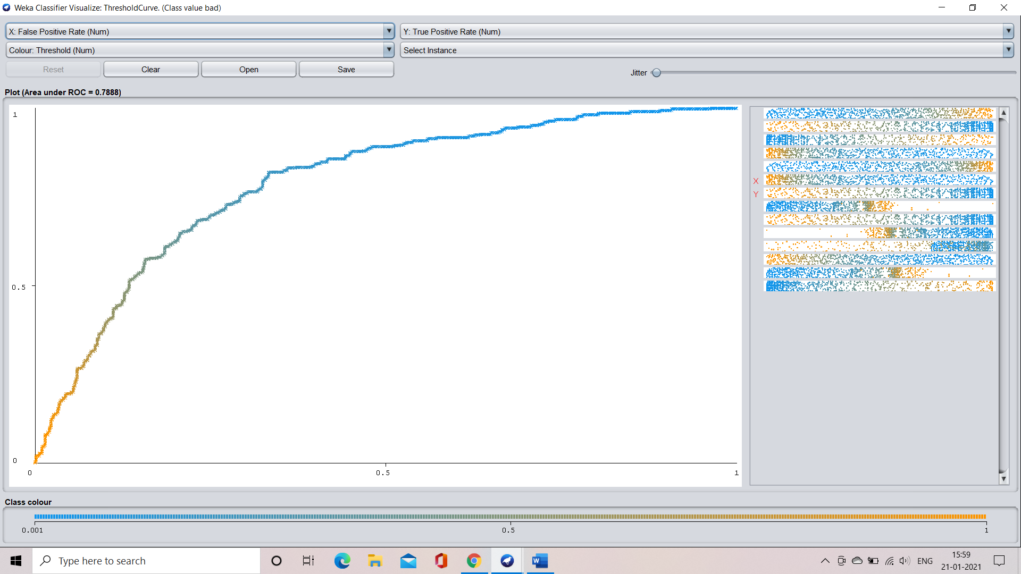

**APPLICATION OF NAÏVE BAYES USING PERCENTAGE SPLITTING**

**CASE 1: application when the splitting percentage is 66%**

**Step 1:** select the percentage split option and specify the required split percentage that is 66% in our case.

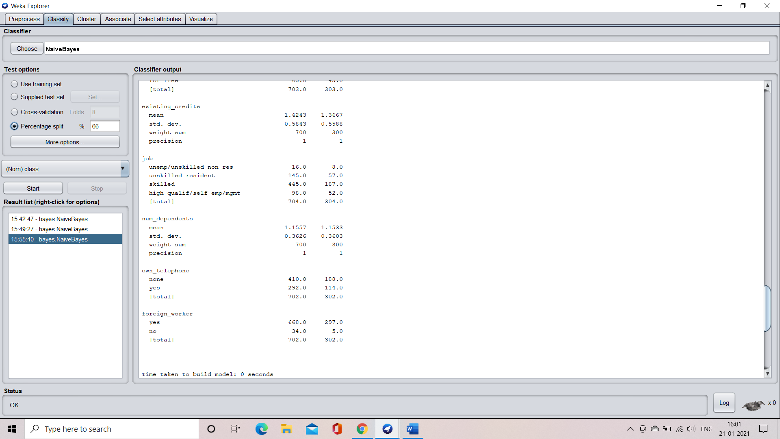

**Step 2:** train the model by clicking on the start button

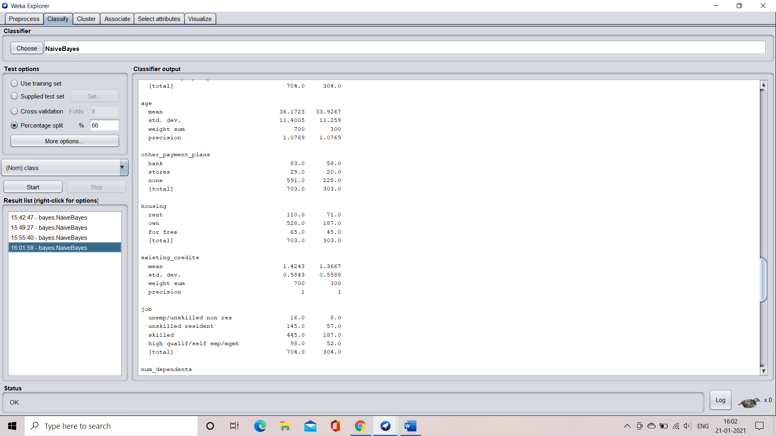

**Step 3:** understand the characteristics of the model

Time taken to build the model = 0 seconds

Time taken to test model on test split = 0 seconds

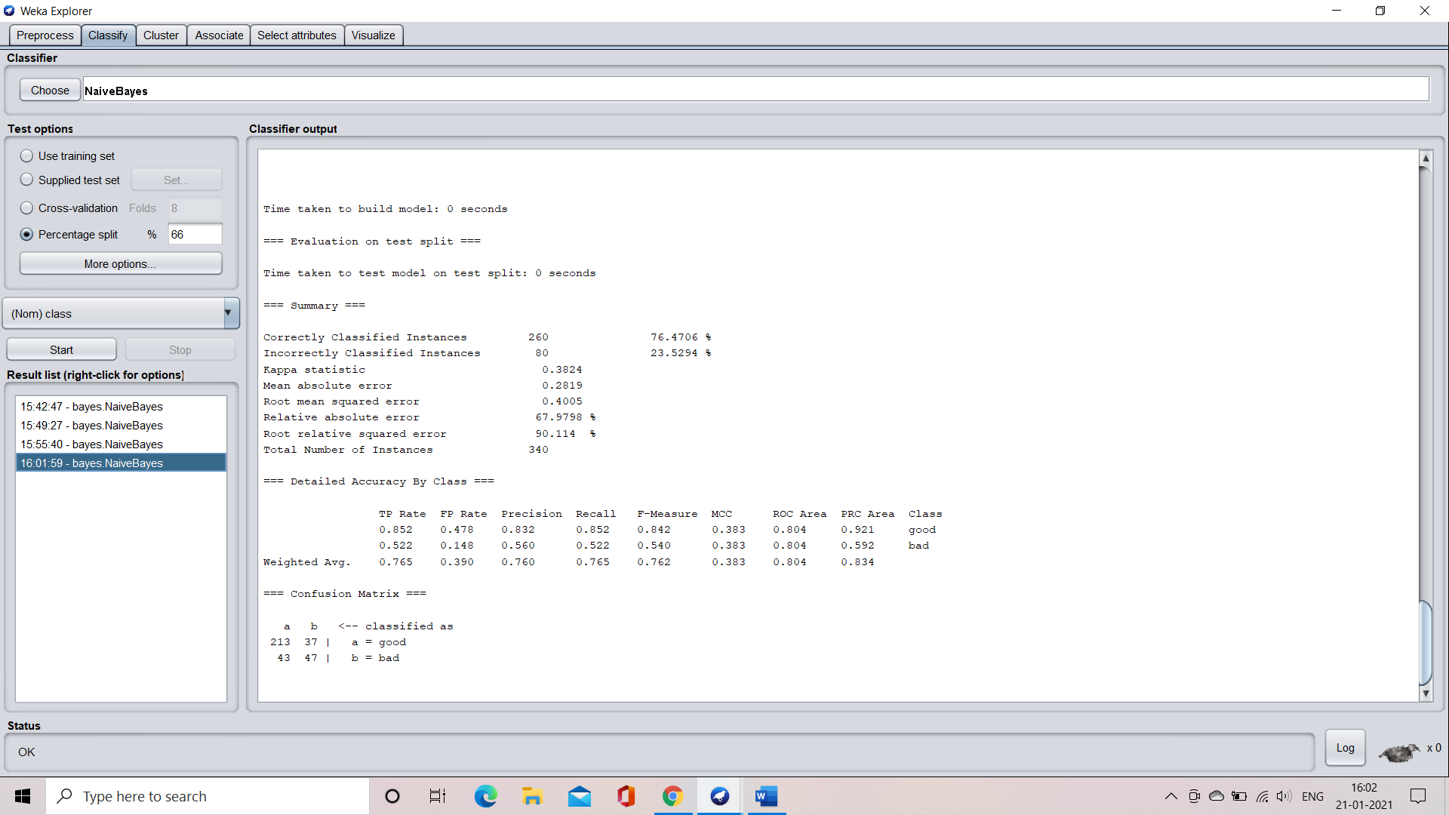

**Confusion matrix:**



**Accuracy:**



**Visualization of the model**

**Margin curve:**

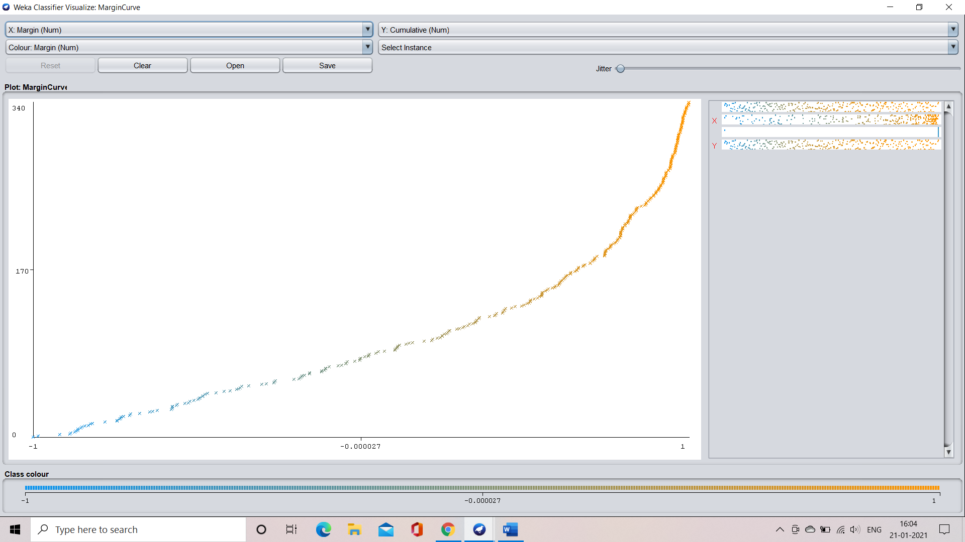

**Threshold curve for the class: good**

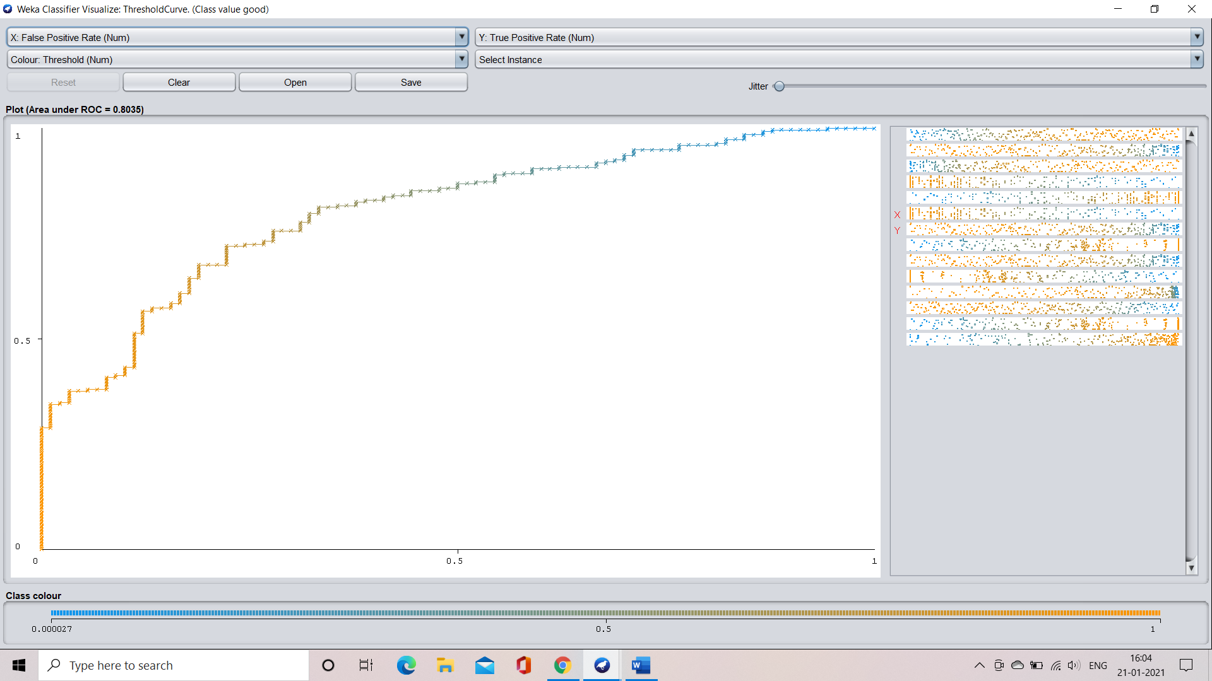

**Threshold curve for the class: bad**

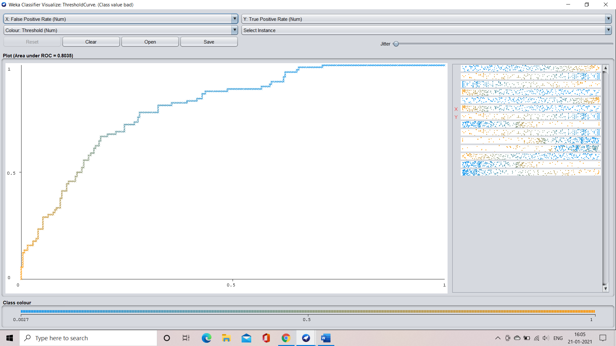

**CASE 2: application when the split percentage is 70%**

**Step 1:** select the percentage split option and specify the percentage required that is 70% in our case

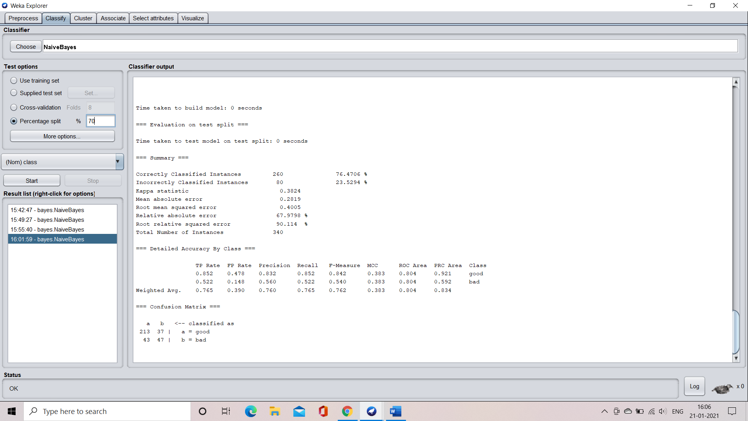

**Step 2:** train the machine by clicking the start button

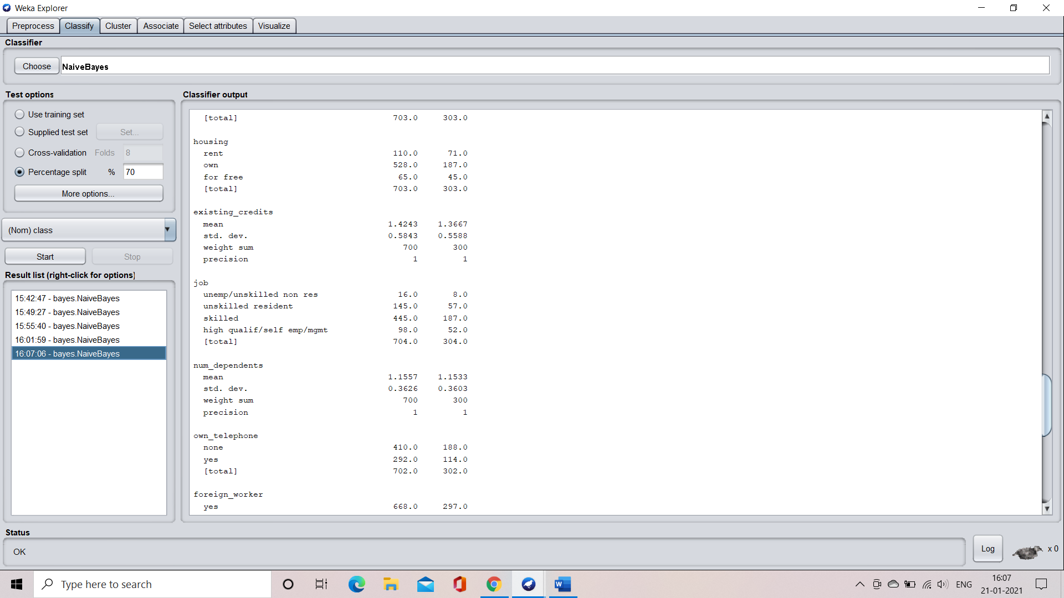

**Step 3:** understand the characteristics of the model

Time taken to build the model = 0 seconds

Time taken to test the model on the test split = 0 seconds

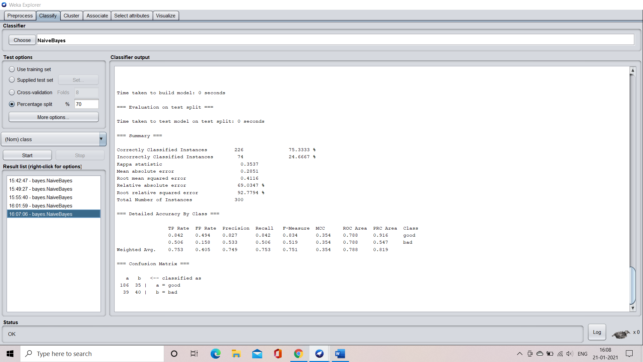

**Confusion matrix:**



**Accuracy:**



**Visualization of the model**

**Margin curve:**

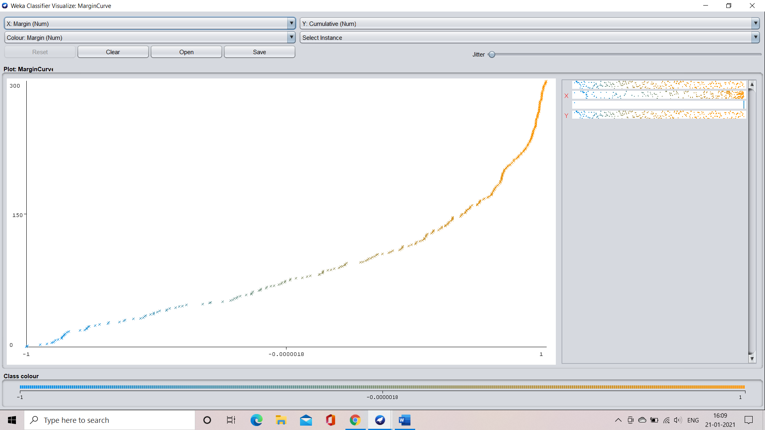

**Threshold curve for the class: good**

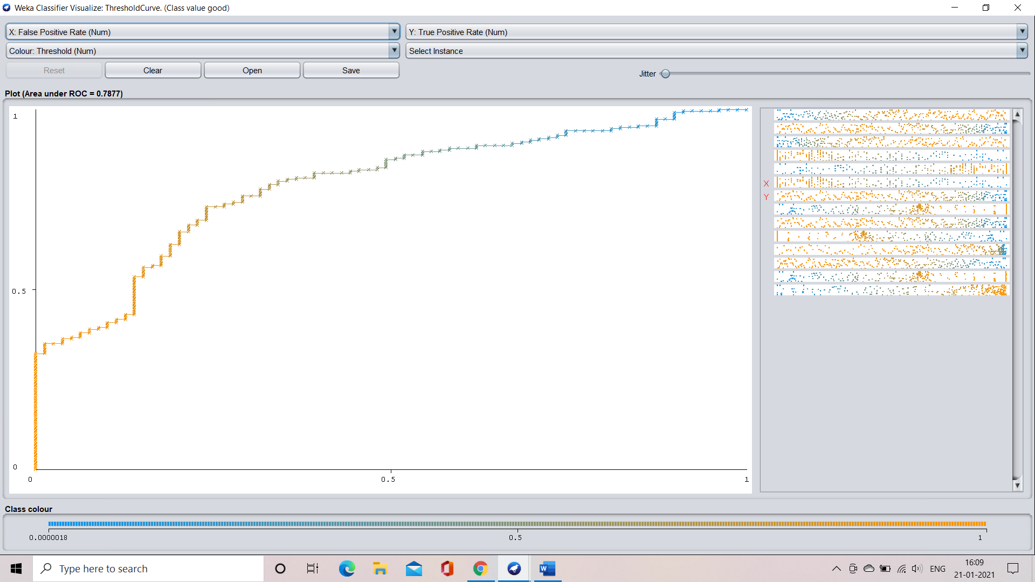

**Threshold curve for the class: bad**

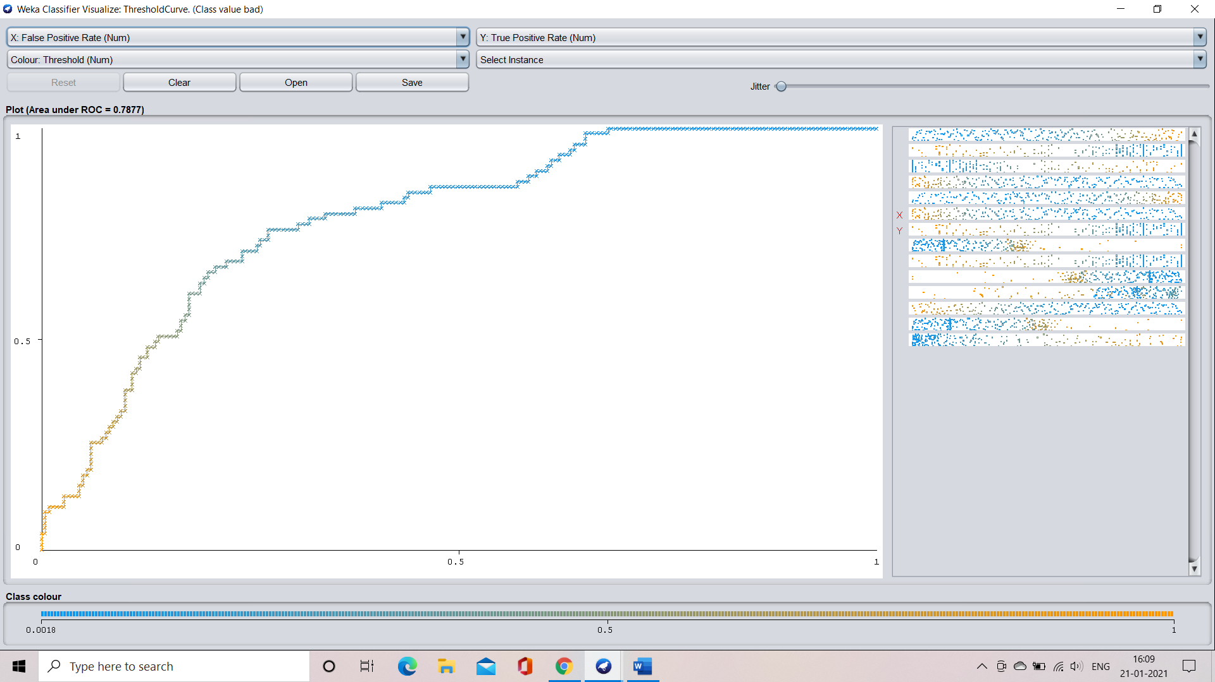

**CASE 3: application when the splitting percentage is 75%**

**Step 1:** select the percentage split option and specify the percentage that is 75% in our case

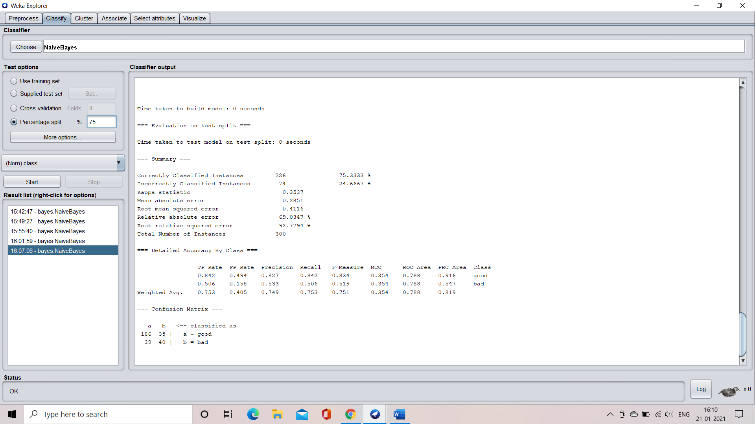

**Step 2:** train the model by clicking on the start button

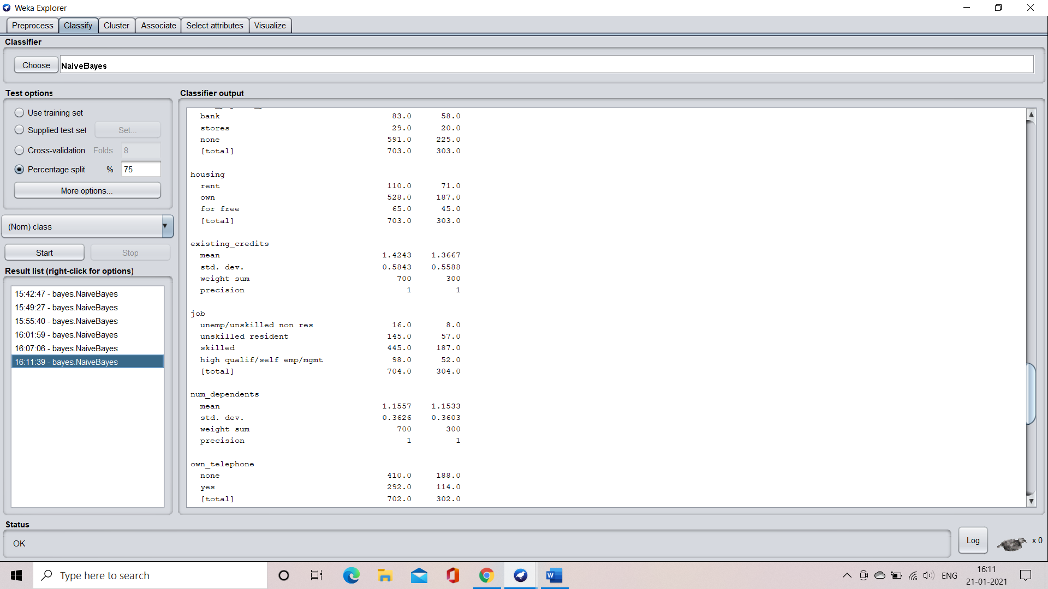

**Step 3:** understand the characteristics of the model

Time taken to build the model = 0 seconds

Time taken to test the model on test split – 0 seconds

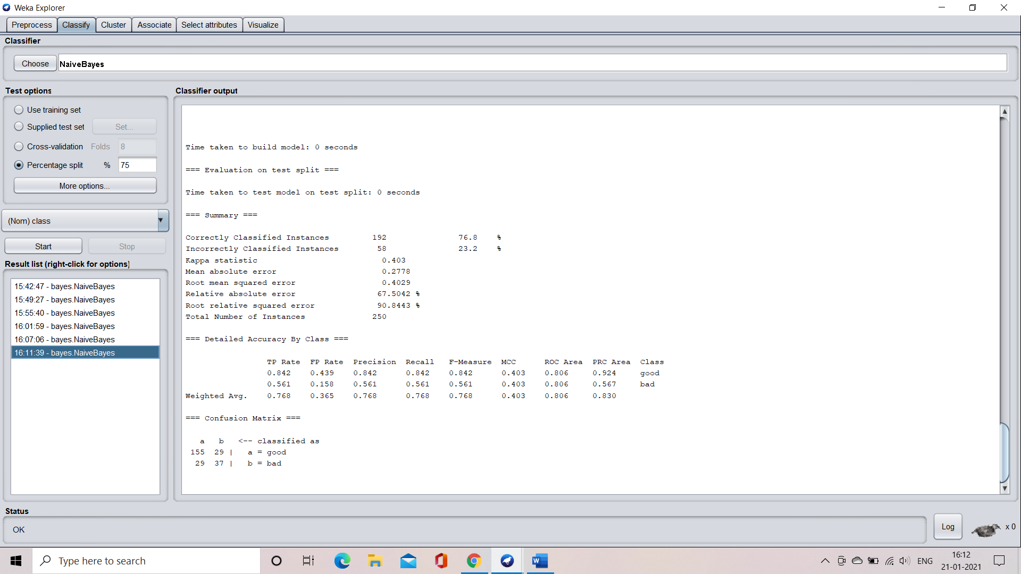

**Confusion matrix:**



**Accuracy:**



**CASE 4: application when the percentage split is 80%**

**Step 1:** select the percentage split option and specify the required percentage that is 80% in our case

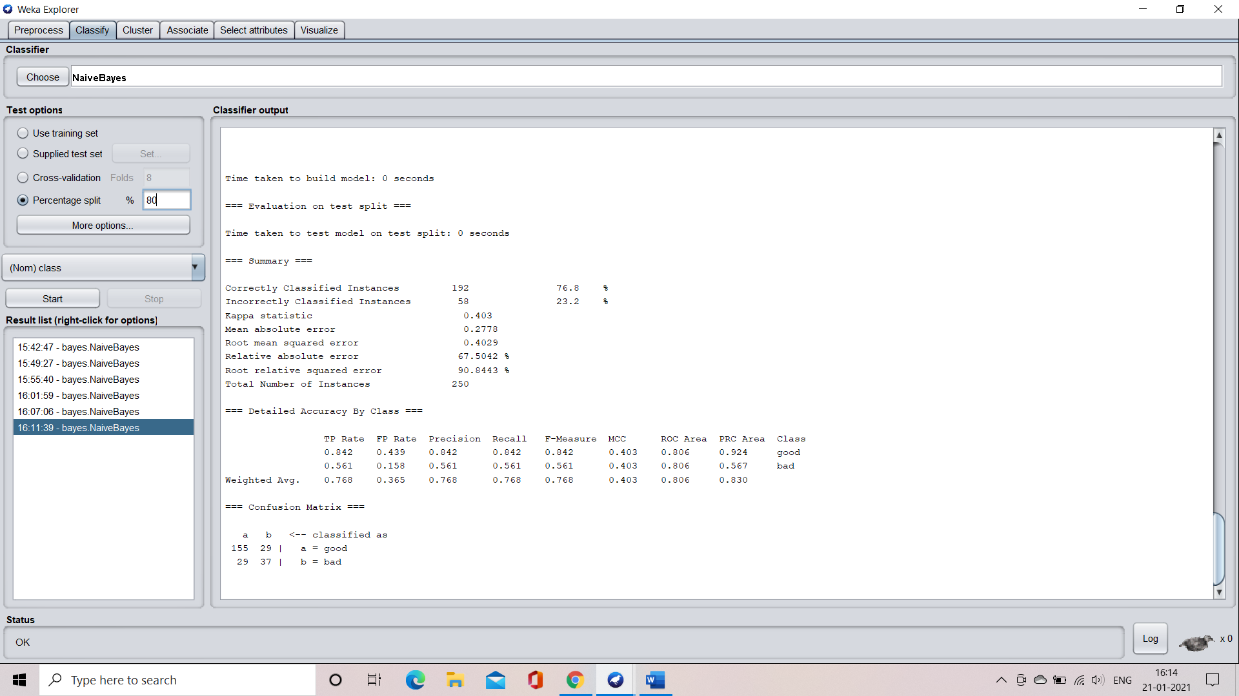

**Step 2:** train the model by clicking on the start button

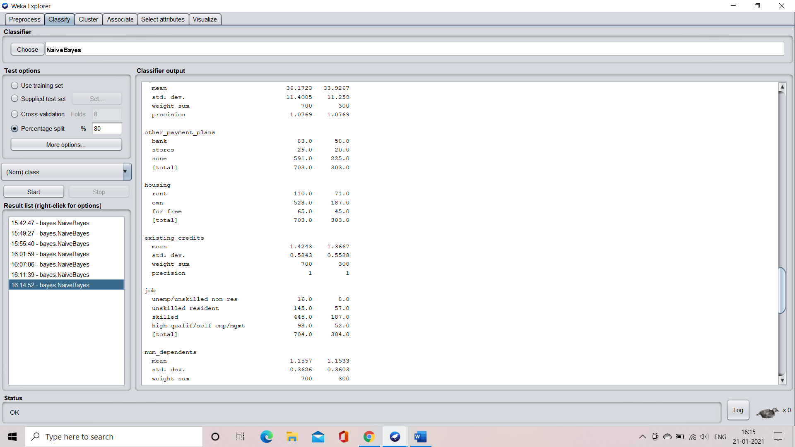

**Step 3:** understand the characteristics of the model

Time taken to build the model = 0 seconds

Time taken to test the model on test split = 0 seconds

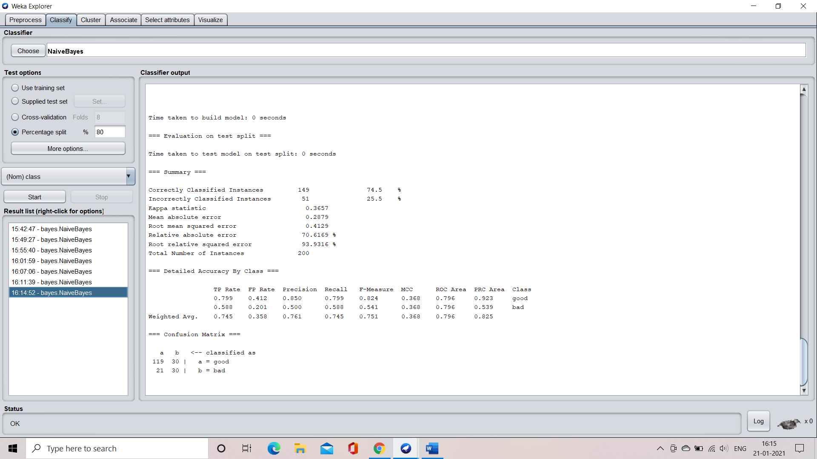

**Confusion matrix:**



**Accuracy:**



**Visualization of the model**

**Margin curve:**

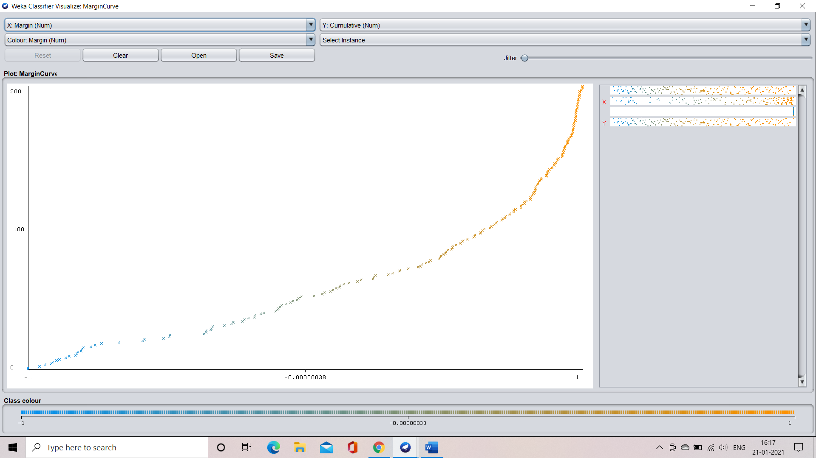

**Threshold curve for the class: good**

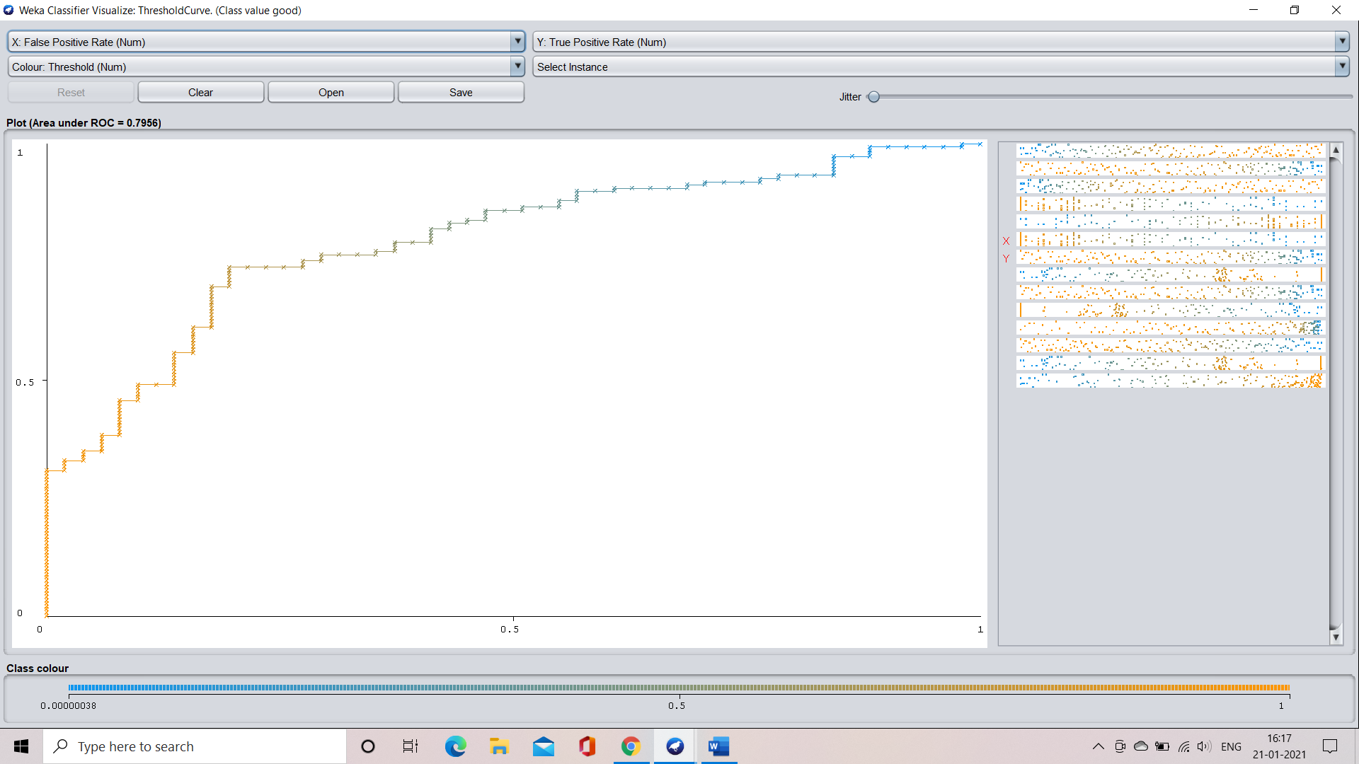

**Threshold curve for the class: bad**

